www.cns11643.gov.tw 台灣中標局

AFP: Advanced Function Presentation
PSF: Print Services Facility

- The following program is used to convert a sequential file in FB format into a member of the AFP font library which is in VBM format.
- How to use it : After a character in a font file has been updated (by using another attached executable : AFPSHOW.exe below), file-transfer the font file via PCOM in BINARY MODE to a predefined sequential file on the mainframe in FB format (LRECL:80 is recommended), then use this program to save the font file back to the font libary. With extreme care on the specification of the output member name. Make sure this is the name of the font member you intend to update.

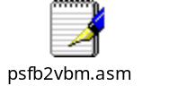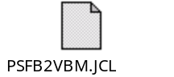

- The following program is used to show and update a character of a font file down-loaded. c0td00d4, c0tc00d4 and c0tb00d4 are samples of the font files down-loaded from the AFP font libary. They are 40x40, 32x32 and 24x24 for codes from 0xD440 to 0xD4FE.
- An MS-paint window will be started up for you to view a particular font and even update it then save back.
- You may create or update the different sizes of the same character at the same time by start more than just 1 AFPShow.exe and copy, paste and even adjust the size in these MS-paint windows being started.

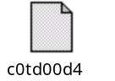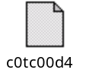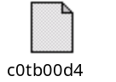

- The following program is used to show and print all characters of the entire font file:
- 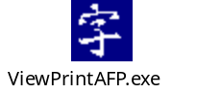

- The following program is used to convert a segment file (normally used to keep a chop shape like the 發票章) into a BMP file. And S1COBKAO is a sample segment file down-loaded from the mainframe whereas s1cobKAO.bmp is the BMP file translated.
- 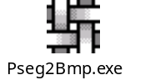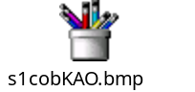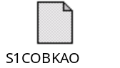

- The following program is used to convert a BMP file back to a segment file. Once updated or newly created (with MS-paint), up-load it to a sequential file in FB format then use the same program : psfb2vbm.asm to save it back to the AFP library.
- 